NEW! Cow patty critters: An introduction to the ecology, biology and identification of insects in cattle dung on Canadian pastures

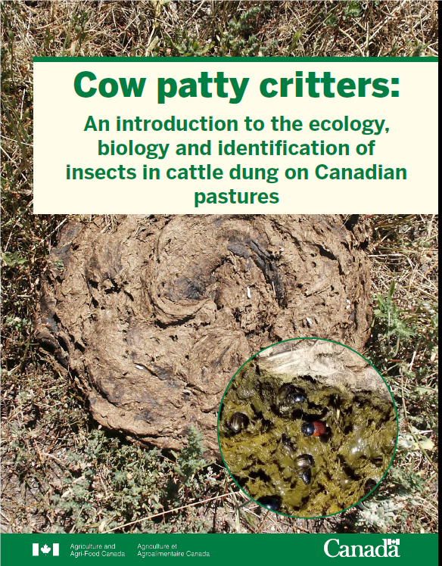
Entomologist Dr. Kevin Floate aims to answer ‘what critters are found in a cow patty?’ and ‘what do they do?’ His hope is to spark the interest of ranchers and farmers, and to stir the minds of students studying insects. In his own words, ‘This is the guide I wish I had when I started my career.’ Insects serve an outsized role in many ecosystem services. For dung on Canadian pastures, there are over 300 species of insects helping to break down and cycle nutrients through the soil and food webs. Understanding what insects are present in a cow patty provide insights into livestock health and ecological processes.

This new 224-page, full color guide provides the ‘doorway’ to learn more about the critters one can find in cow dung: how to identify them, how they can be beneficial, and additional information on the biology and morphology of multiple insect groups. Also included is an extensive reference list
(glossary, bibliography sources) for those who wish
to pursue detailed insect identification.

What you will find inside:
- Part I: General ecology of the dung insect community
- Part II: Identification of dung-breeding insects
- Part III: References
- High quality colored photographs

Book Description
Author: Kevin Floate

Published by: Agriculture and Agri-Food Canada, Lethbridge, AB

Pages: 224
Languages: English and French
French Title: Ces bestioles qui raffolent de la bouse : Introduction à l'écologie, à la biologie et à l'identification des insectes présents dans la bouse des bovins en pâturage au Canada
Dimensions: 21.6 x 28 cm/8.5 x 11 inches (portrait)
Document numbers:
- ISBN : 978-0-660-44755-1
- Catalogue Number: A59-90/2022E-PDF
- Department Number: AAFC No.: 13130E

Floate, KD. 2023. Cow patty critters: An introduction to the ecology, biology and identification of insects in cattle dung on Canadian pastures. Agriculture and Agri-Food Canada, Lethbridge, Alberta, Canada. 224 pp.

Free Download Free Download (pdf) available here: Search for digital version Cow Patty Critters from www.publications.gc.ca or scan the QR code below.

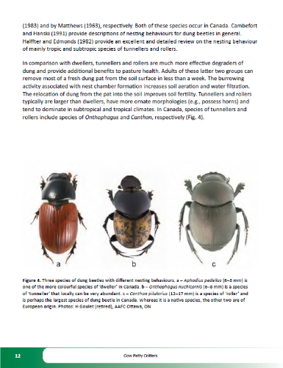
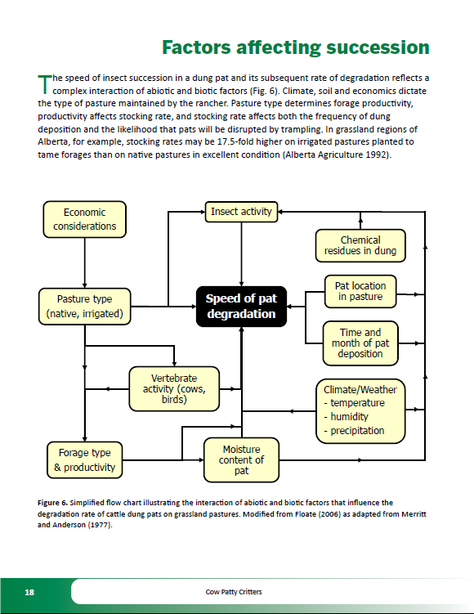

For more information, reach us at https://agriculture.canada.ca/en , by email at aafc.info.aac@agr.gc.ca or by calling toll-free at 1-855-773-0241

